3-TIER ARCHITECTURE

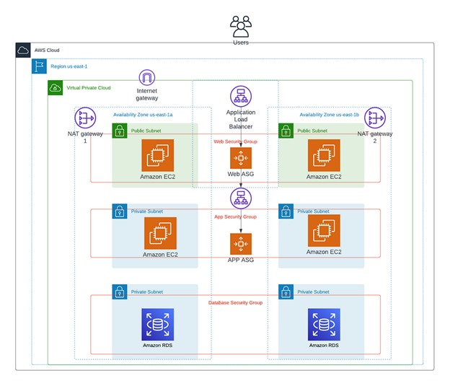

**First Create The VPC [virtual private cloud]:**

Step 1: Create a VPC.

Step2: Create a 6 Subnet 2-public subnet,4-private subnet. Create the Take one Availability Zone 3-subent are connect the one subnet public and two private subnet.

Step3: Create a Internal Gateway and Attach the VPC.

Step4: Create a Route table and attach the public subnet. Go to Routes click the edit routes and Add Route attach the Internal Gateway and click the Sub Associations choose option edit sub association select the public subnet.

Step5: Create a Route table To attach the private subnet. Go to Routes Click the edit routes Add Route attach the NAT gateway and click the Sub Associations choose option edit sub association the private subnet.

Step6: Create the NAT gateway. Create a new Elastic IP Allocate.

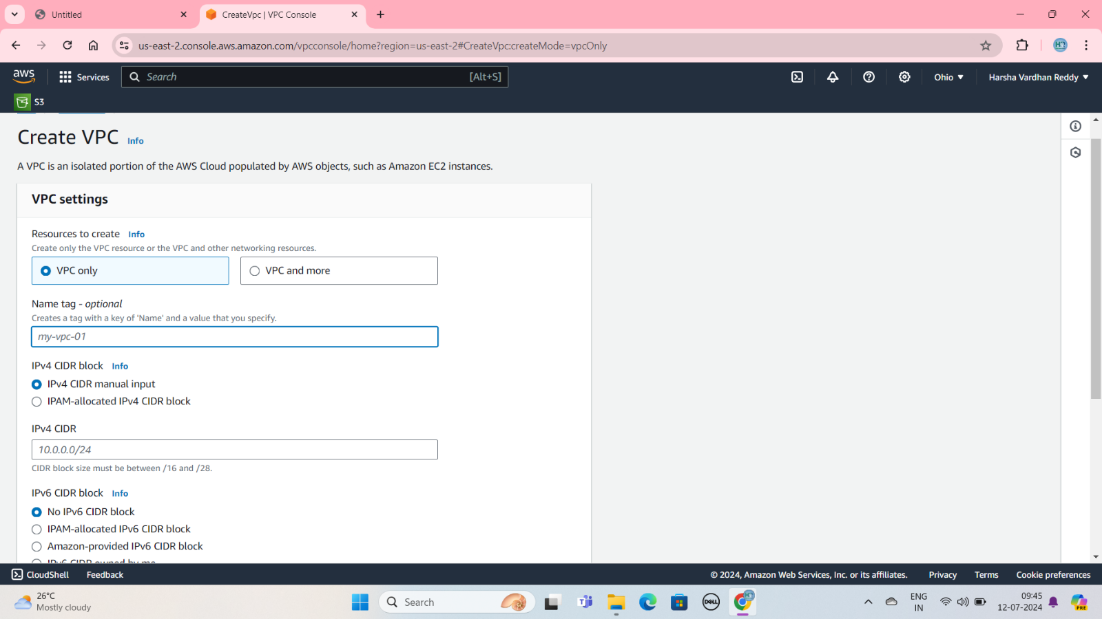

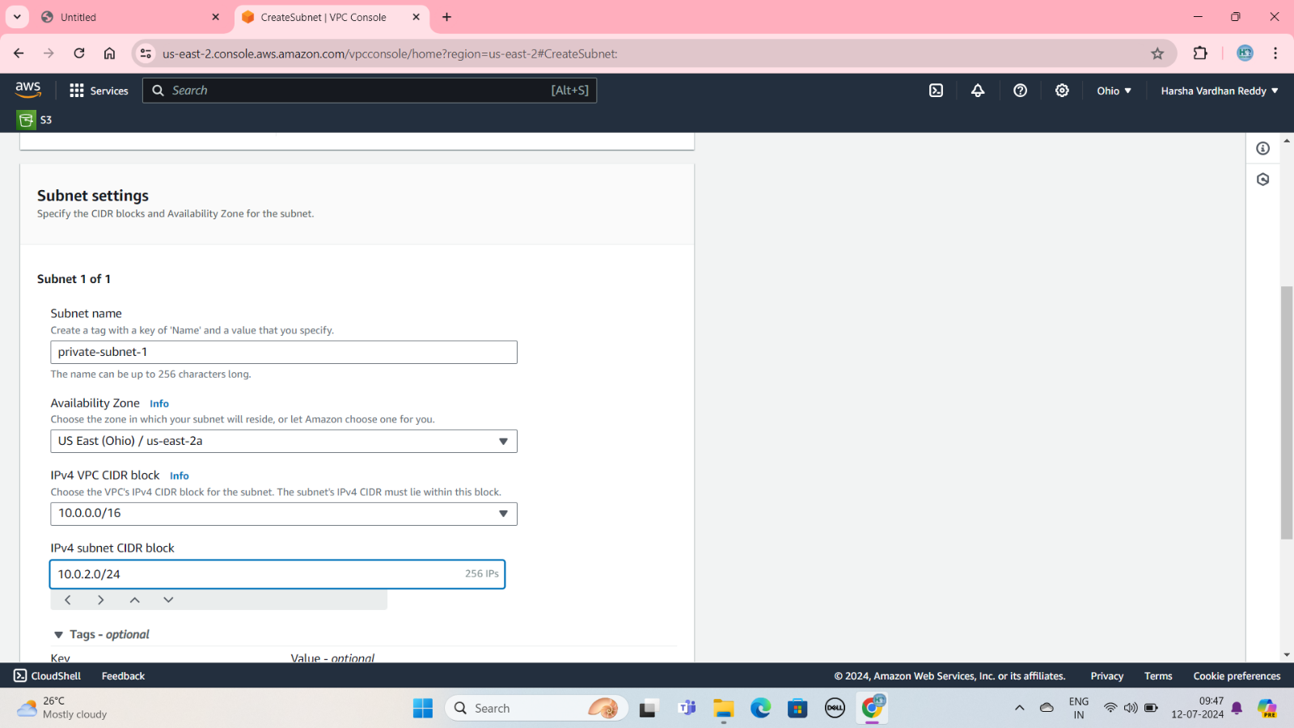

Public subnet and private subnet:

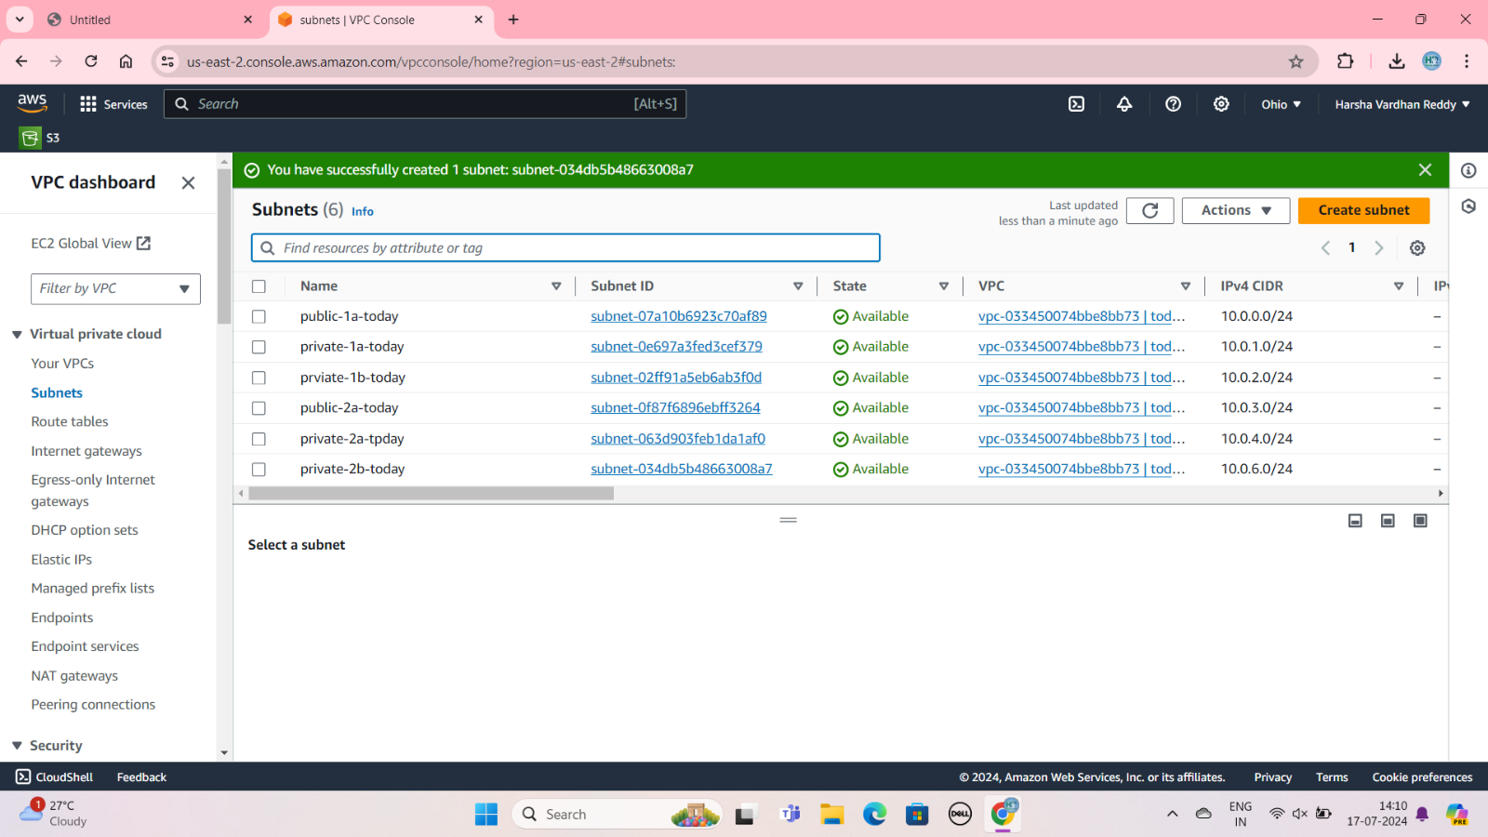

Create Route Table:

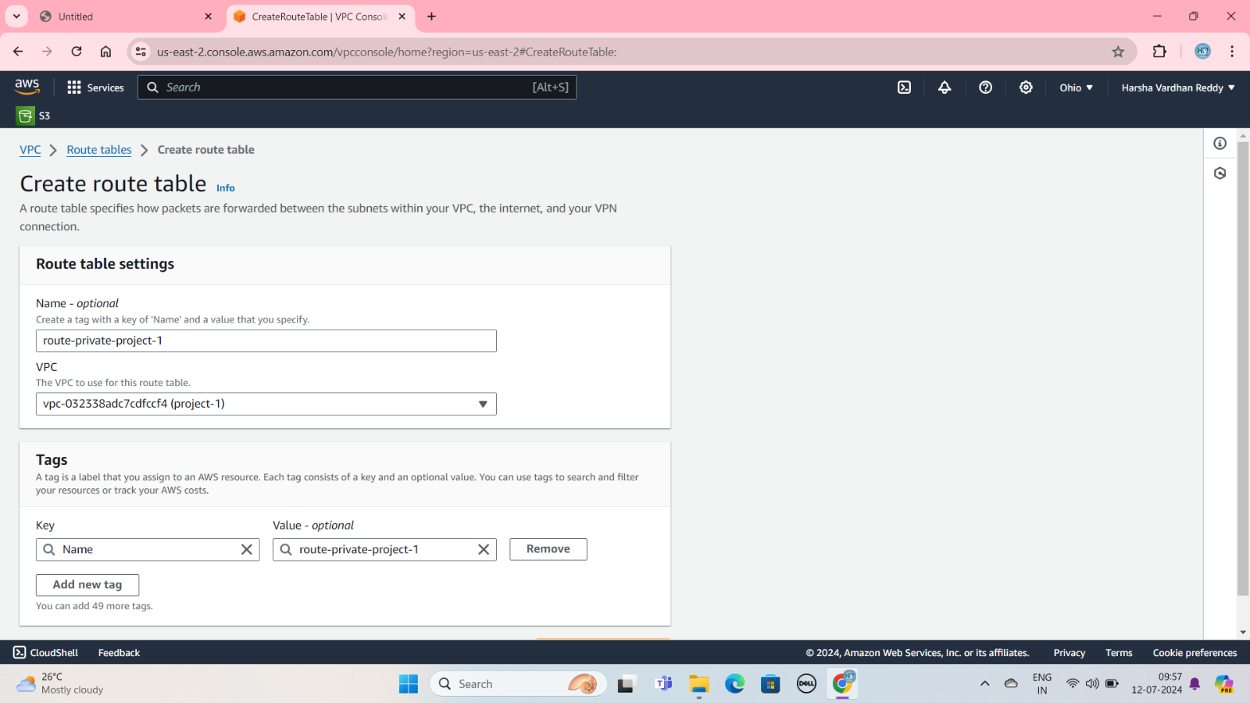

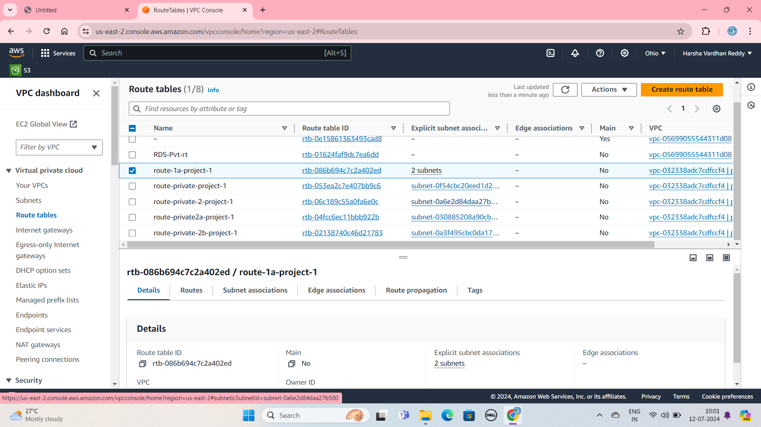

Internet Gateway Attach with VPC

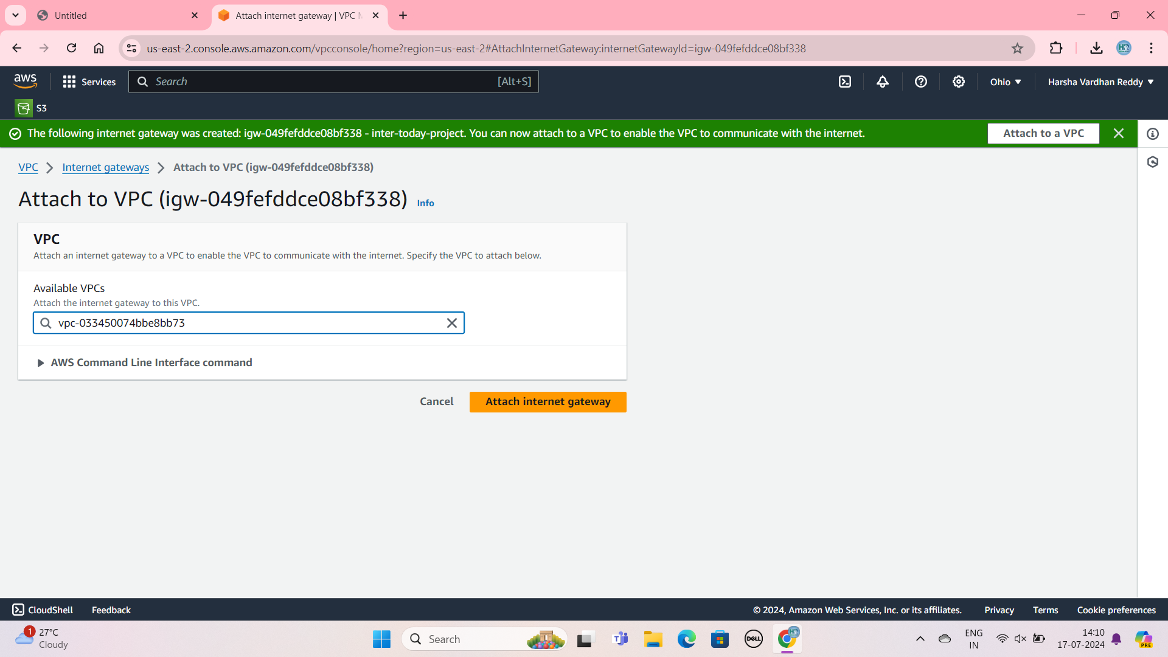

Two Nat Gateways Connect With Two Public Subnet Different AZ:

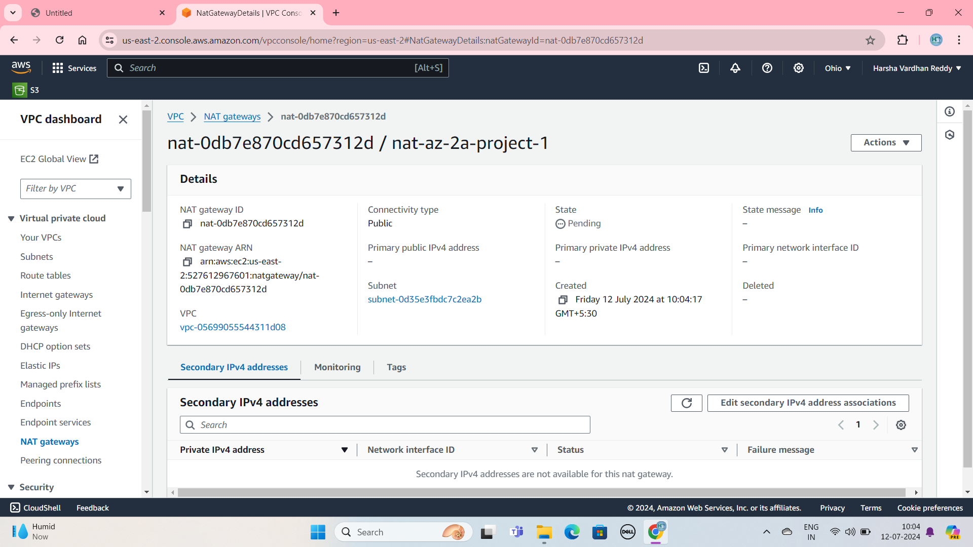

Create Two NAT Gateway Different ZONE:

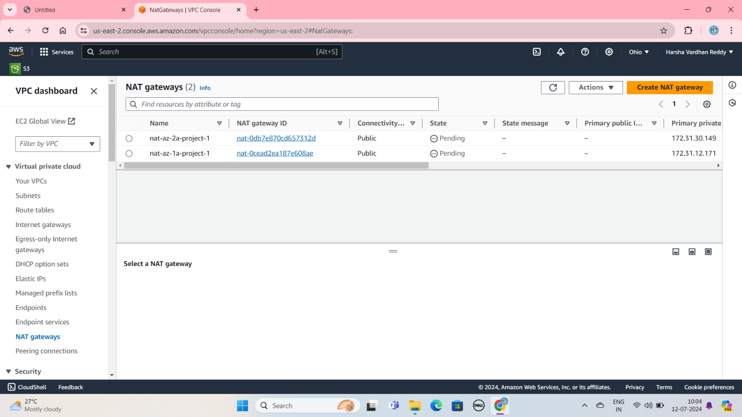

Private RouteTable Add Route Attach With NAT Gateway

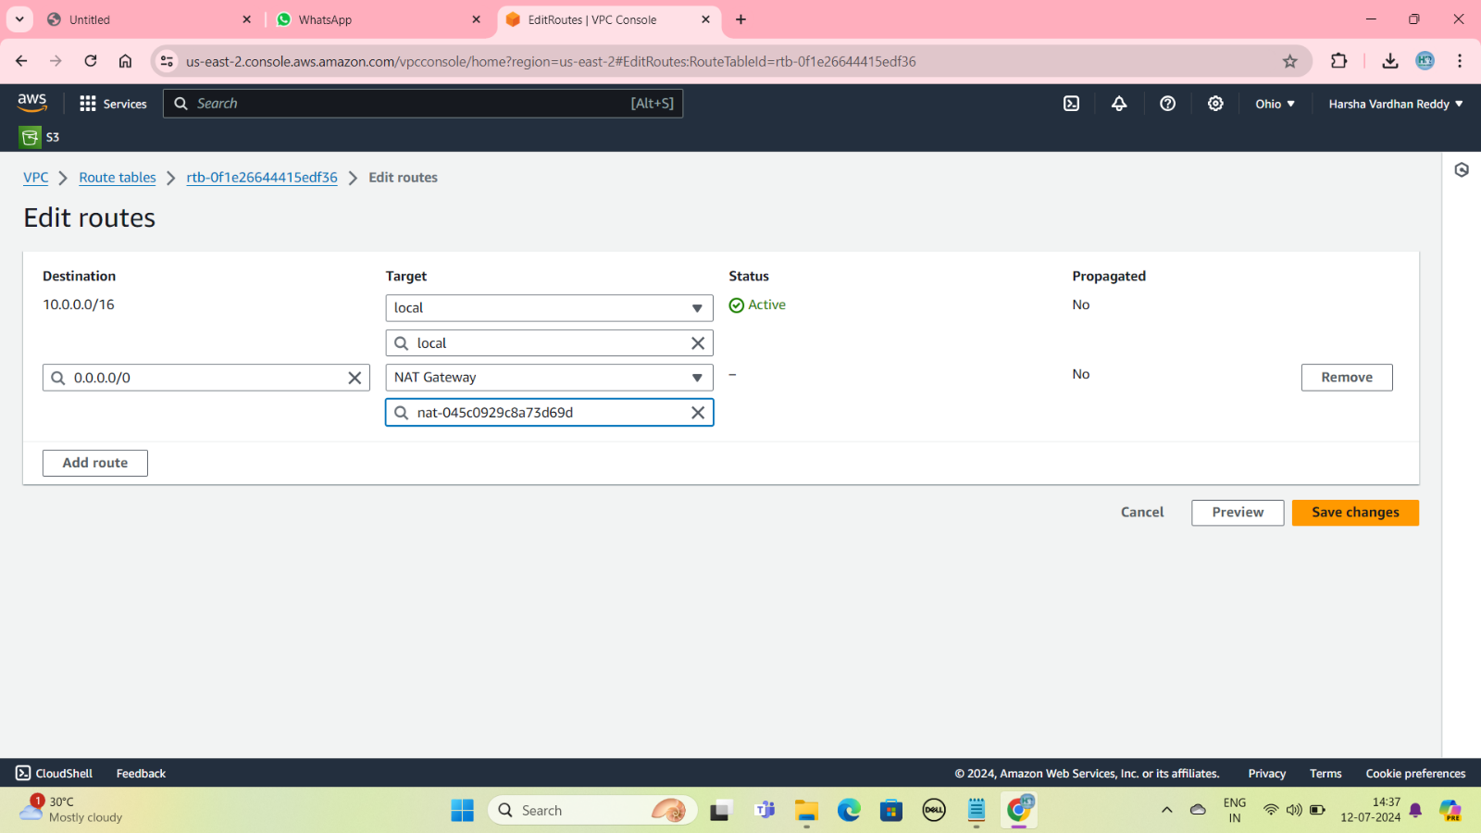

**Second Create the EC2 Instance:**

**Step 1: Sign in to the AWS Management Console.**

**Step 2: Click On The Launch Instance.**

**Step 3:  Provide a name of your instance.**

**Step 5:** On the Quick Start tab of the Choose an Amazon Machine Image**. Choose an Instance Type.**

**Step 6: Create a key pair.**

**Step 7: Go to Network Setting and Click the edit, select the vpc and select the public subnet and select the private subnet connect the ec2 instance one Region.**

**Step 8: Create the Security Group.**

**Step 9: Review and Launch.**

**Create The Security Group:**

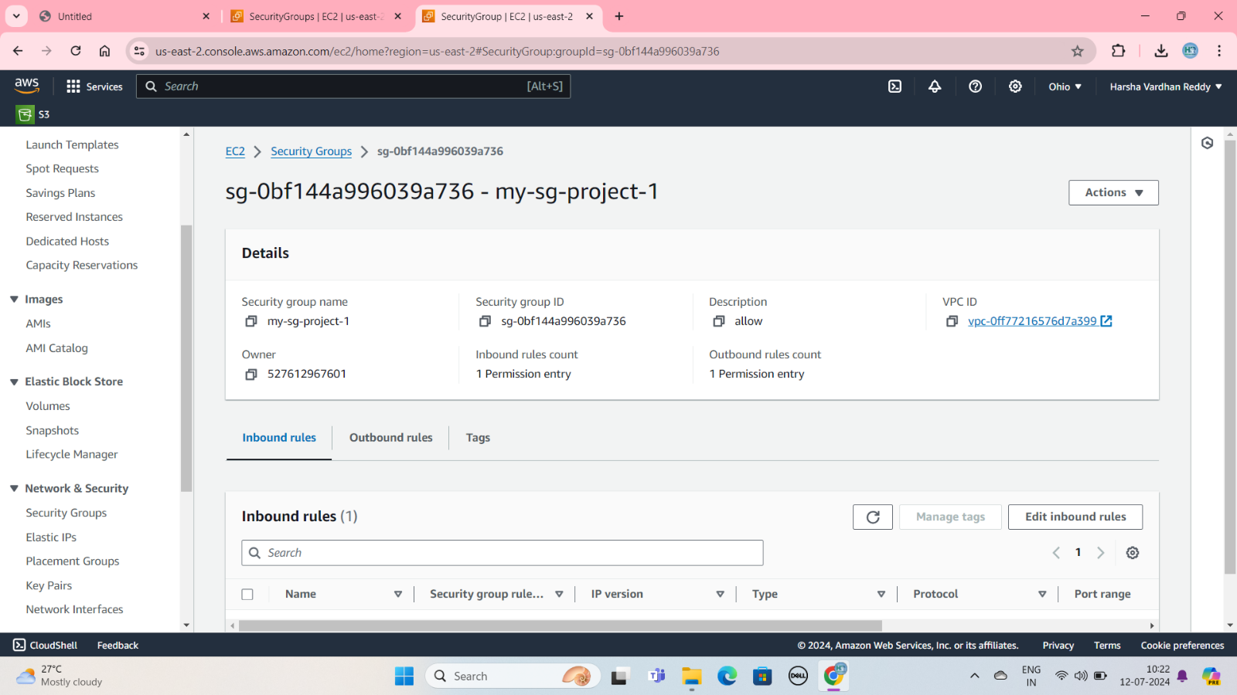

**Create The Ec2-Instance:**

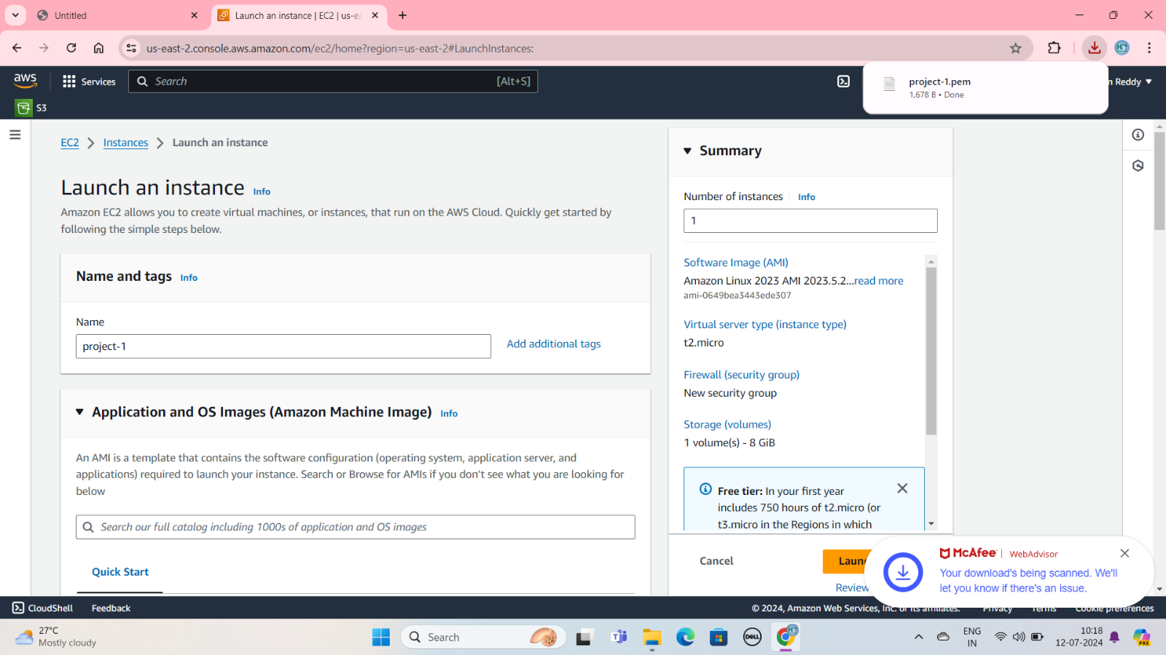

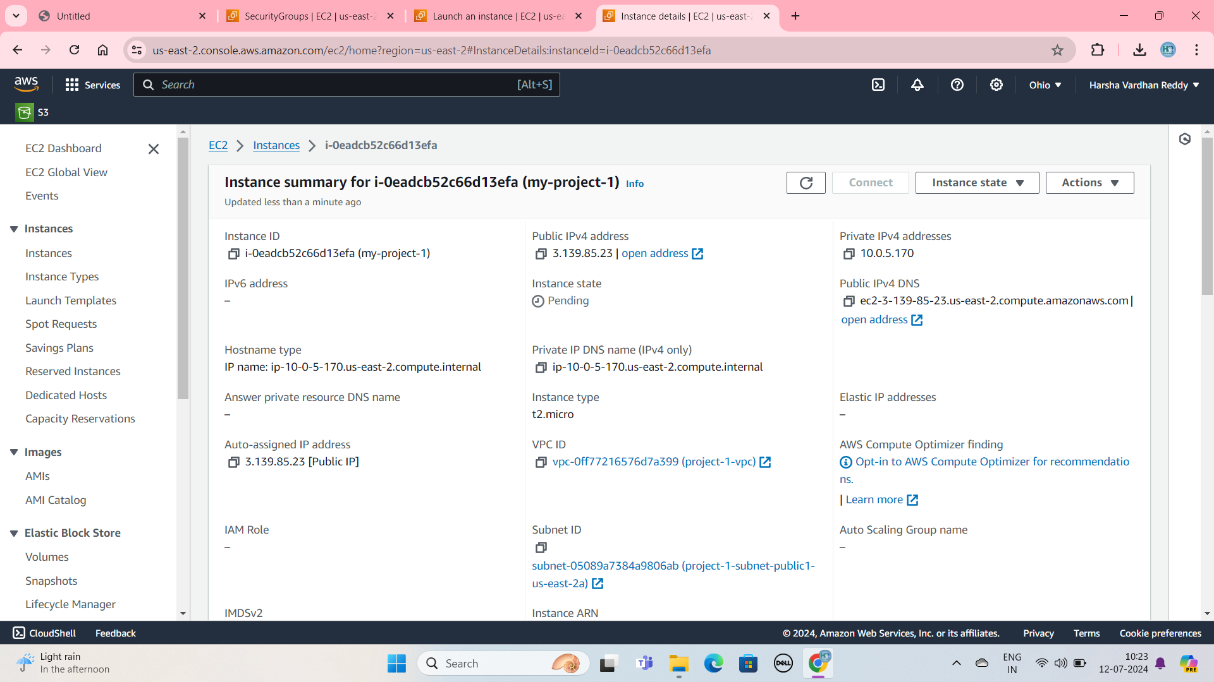

**Third Create the Load balancer and Target Group:**

Step1: Create the Target Group and choose a target type is instances. Enter the Target group name .

Step2: Create VPC is select. next and click the ec2 instance and include as pending below click and Create Target Group.

Step3: Create the Load Balancers type is Application load Balancer.

Step4: Enter the name and select the vpc. click the ec2 instance click.

Step5: Select the security groups and Select the Target group.

Create the target group:

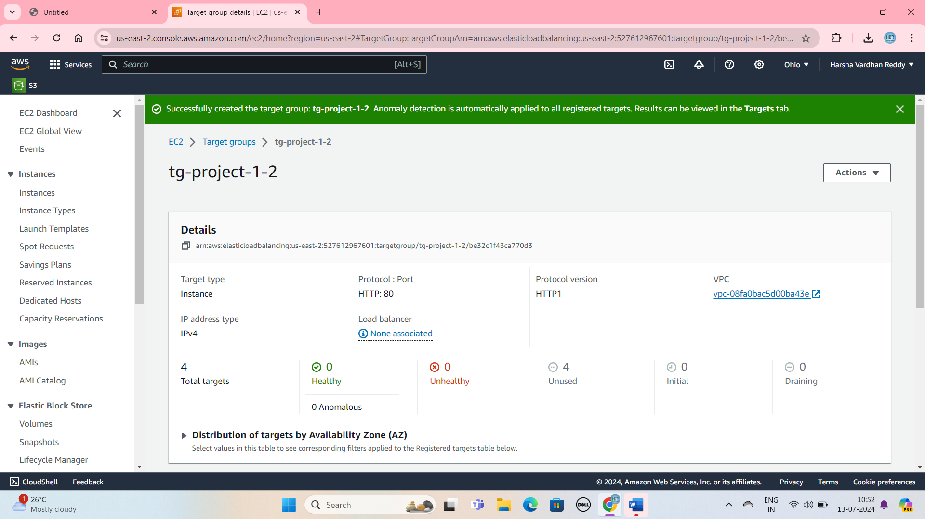

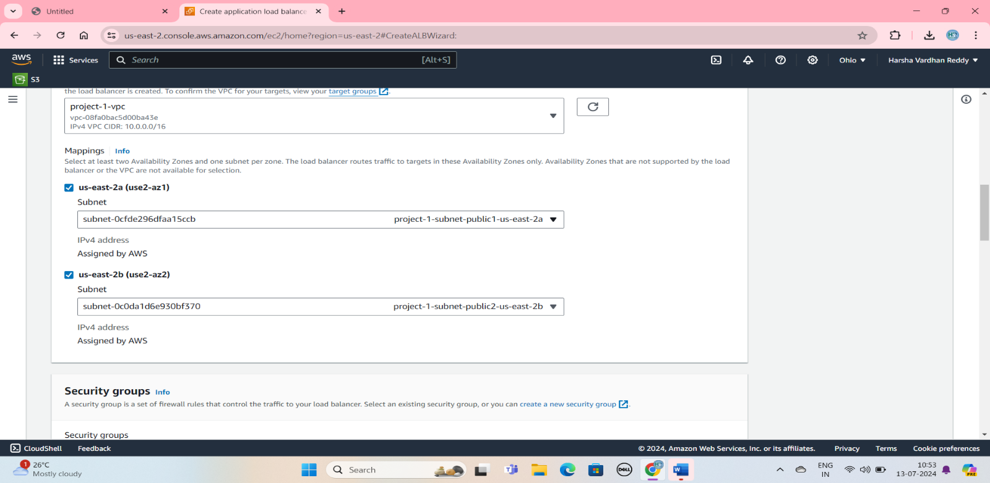

Create the Load Balancers:

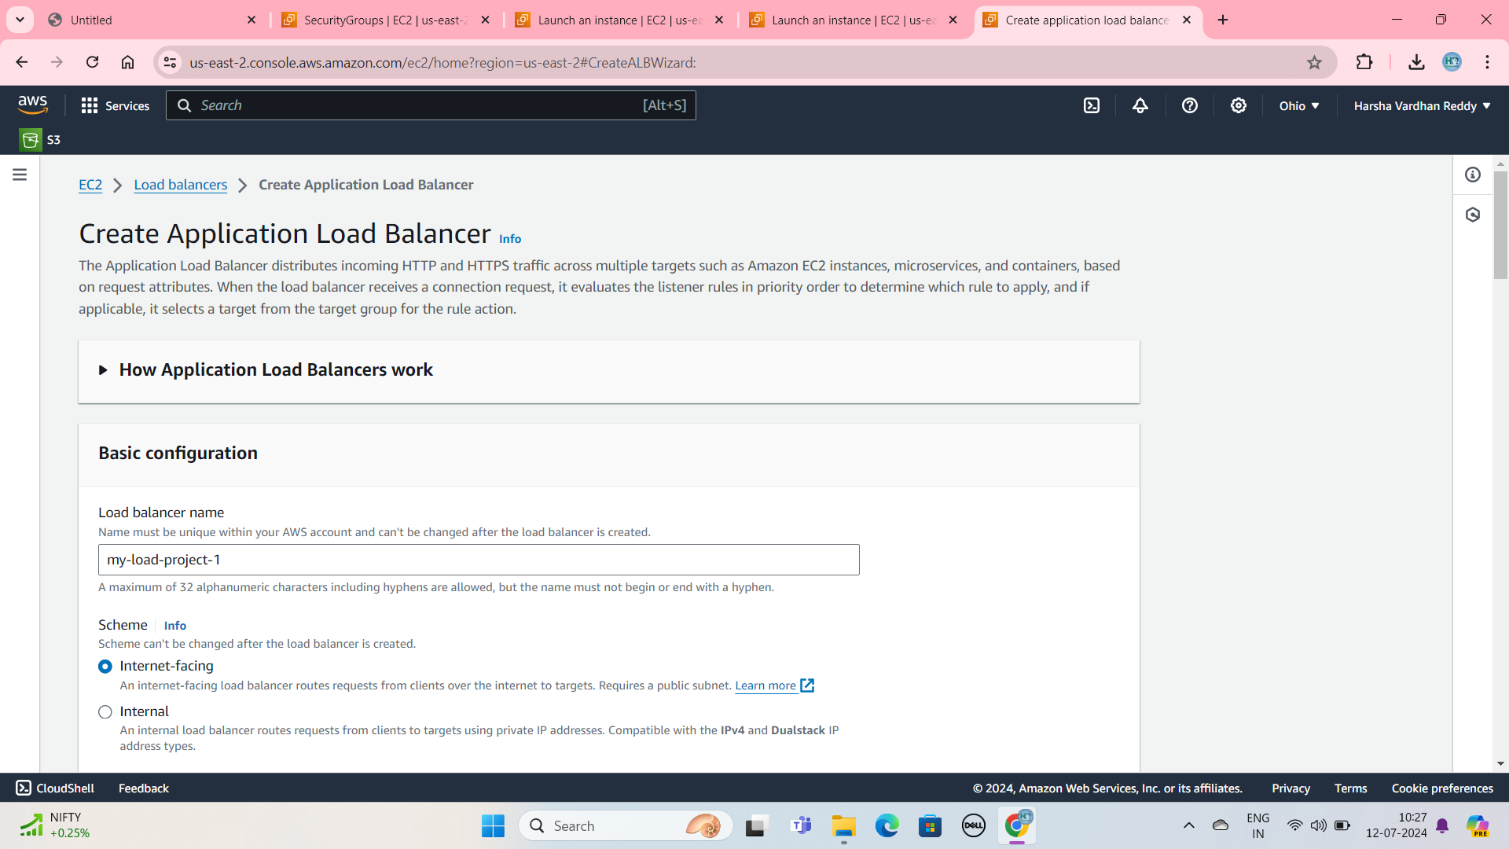

Install the Nginx:

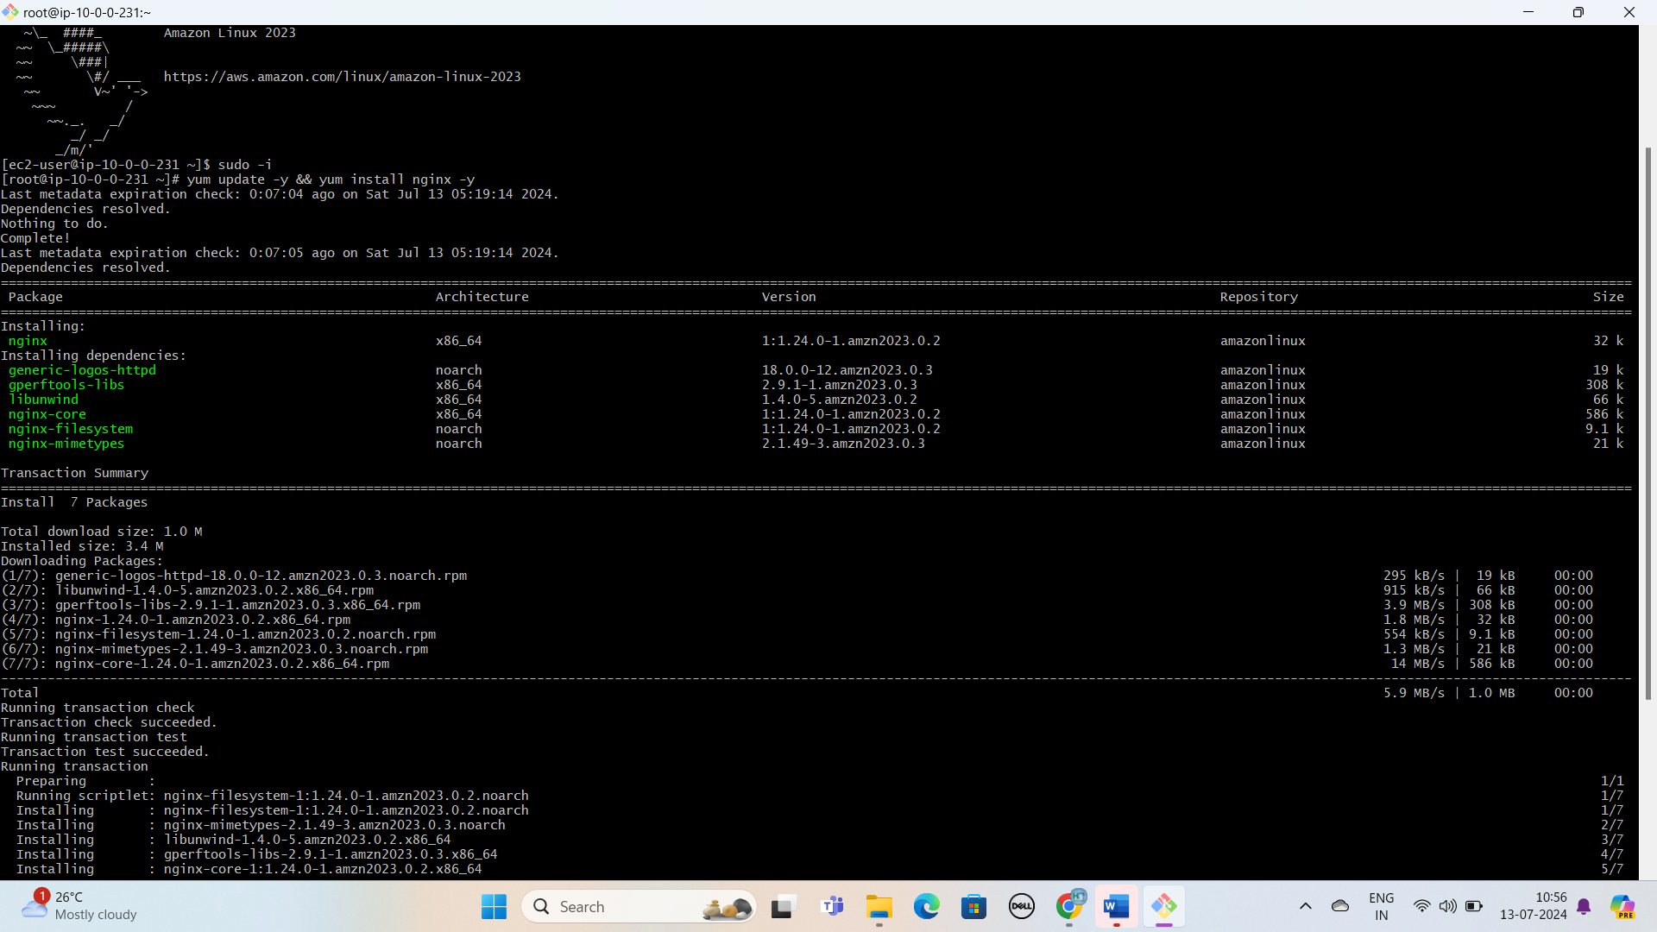

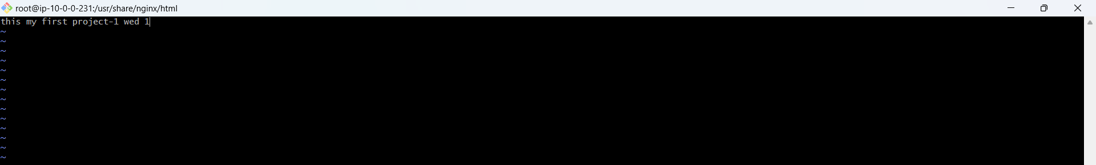

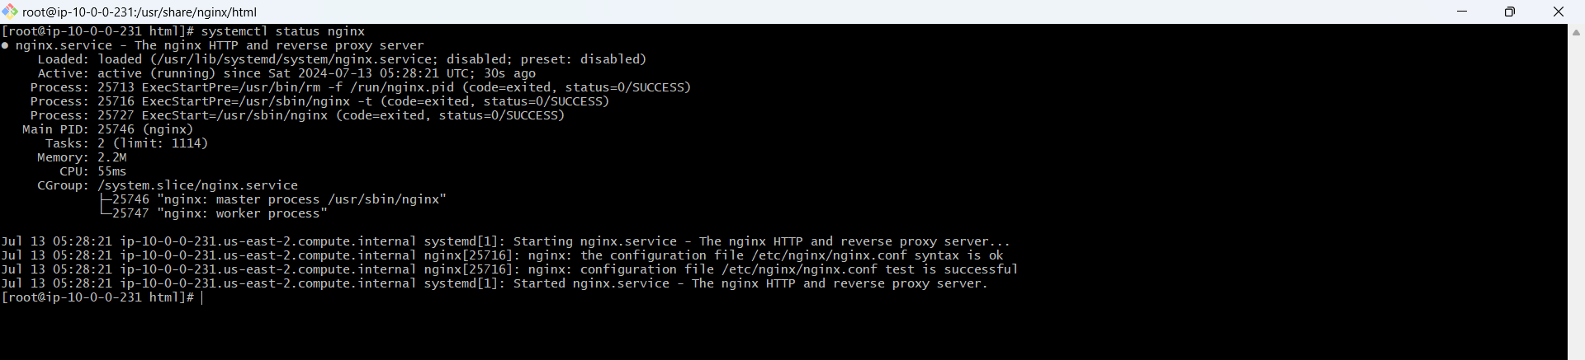

OUTPUT: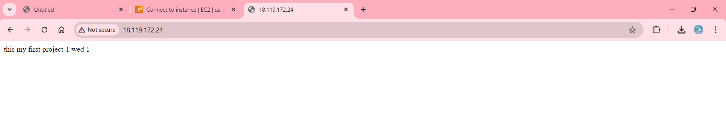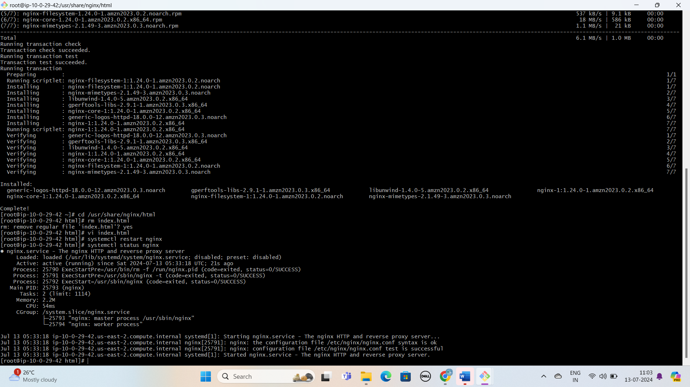

OUTPUT: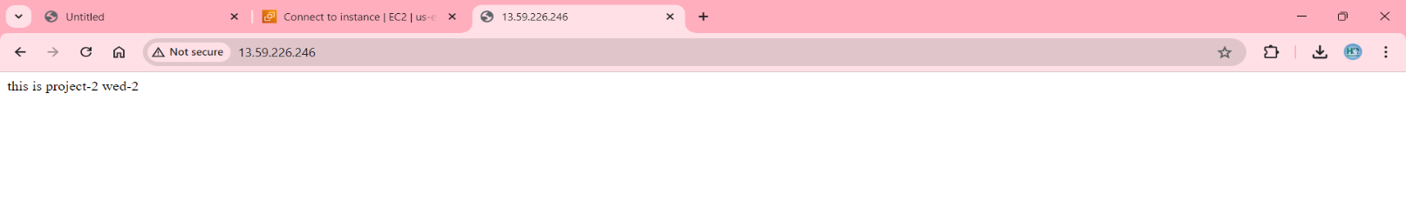**AUTO SCALING GROUP:**

Step1: Click the Auto Scaling Group and Enter the name, click the Create a Launch Template.

Step2:On the Quick Start tab of the Choose an Amazon Machine Image**. Choose an Instance Type**

**Step3: Create a key pair and select the Security Group. Create Launch Template.**

**Step4: Select the Launch Template and click the next Button.**

**Step5: Select the VPC and Select the Availability Zones and Subnet.**

**Create the Auto Scaling:**

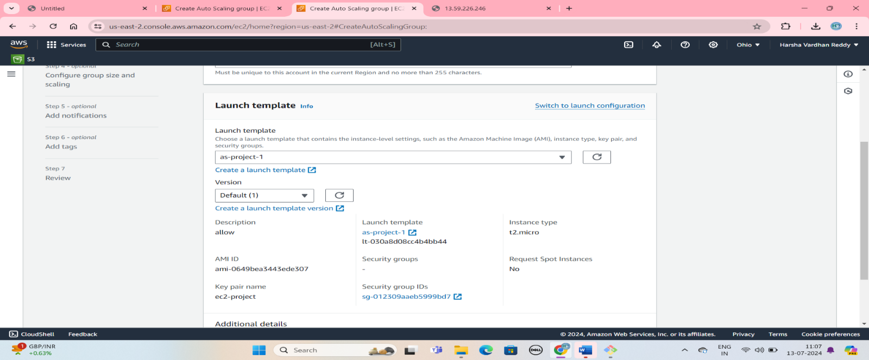

Target Group is Attach to load Balance:

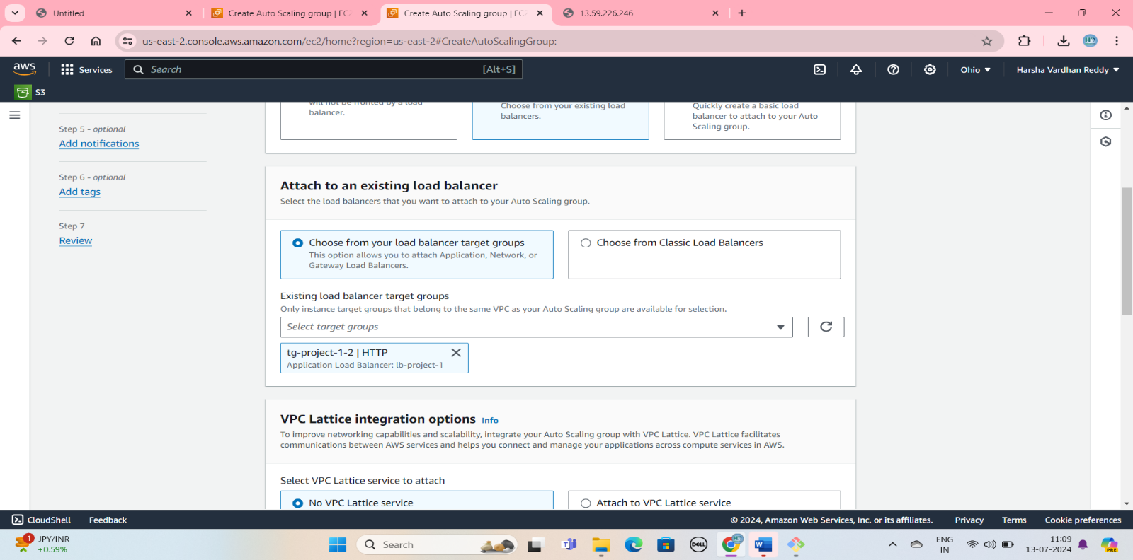

Auto Scaling use EC2 instance Will be increase:

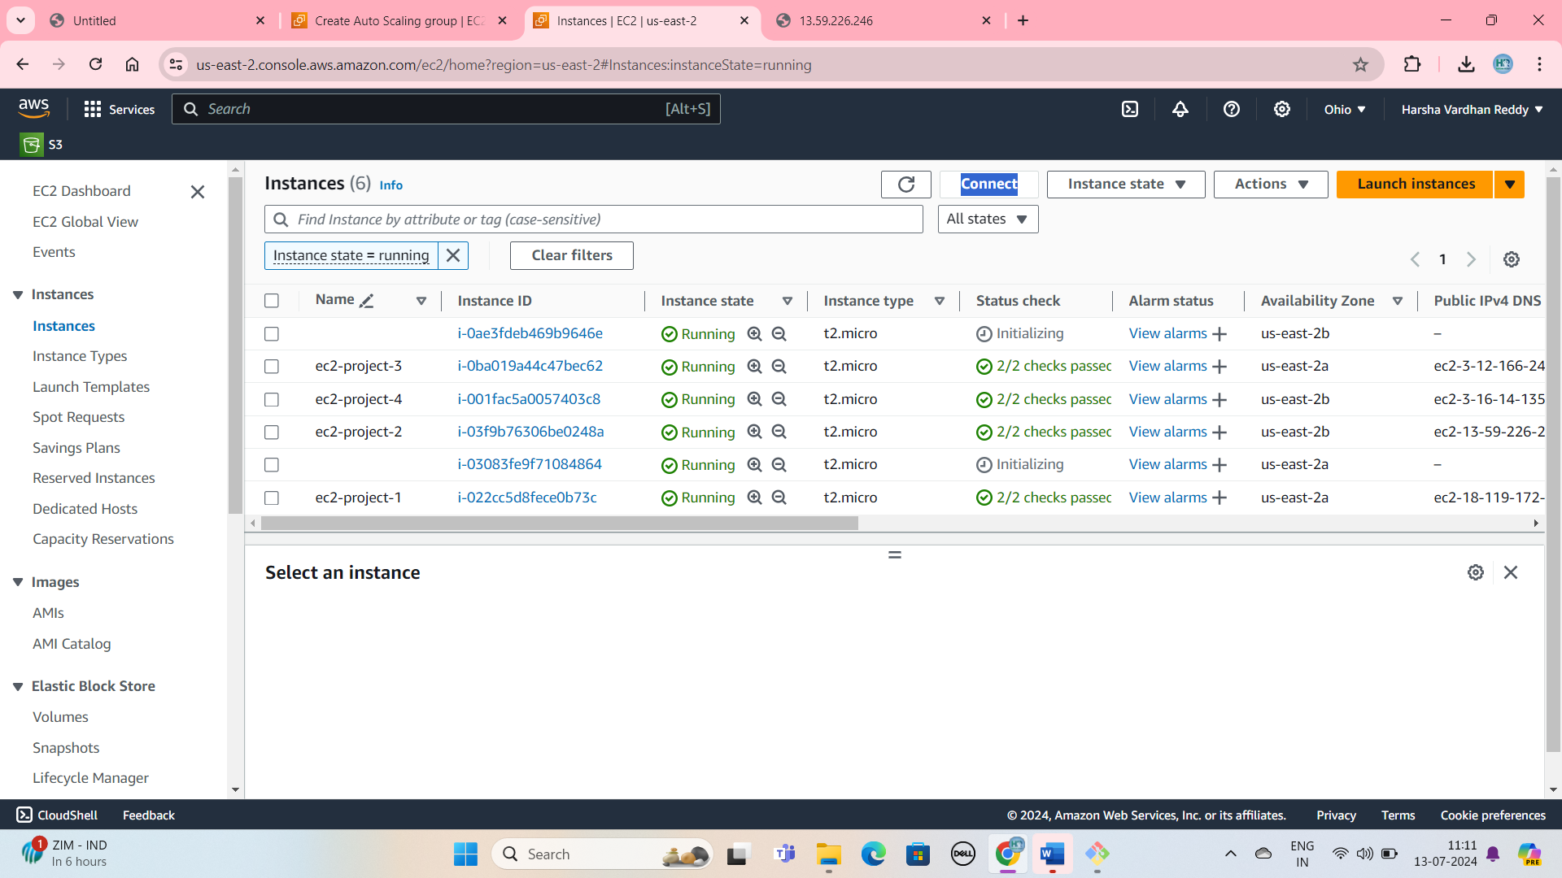

**RDS (Relational Database Service):**

Step1: From the Region selector (at top right), choose an AWS Region. The database and the EC2 instance must be in the same Region in order to use the automatic connection feature in the EC2 console. Create the EC2 instance

Step2: Click the Database and Select the Standard create. And Engine options, for Engine type, choose “MySQL”.

Step3: For DB instance identifier, enter a name for the database. For this tutorial, Enter Name of Data Base

Step4: For Master username, leave the default name, which is admin. and select the self-managed. Enter the password

Step5: choose the connect to an EC2 compute. and connect the EC2 instance and connect the VPC. Add the security Group. Click the create database.

Step6: before the MYSQL-Server was Install in Amazon linux .RDS wait for Available Status and Endpoint copy and go to Amazon Linux “mysql -h endpoint paste -u admin -p”.

Create the RDS and select the Standard Create and Select the Engine Options “MYSQL”

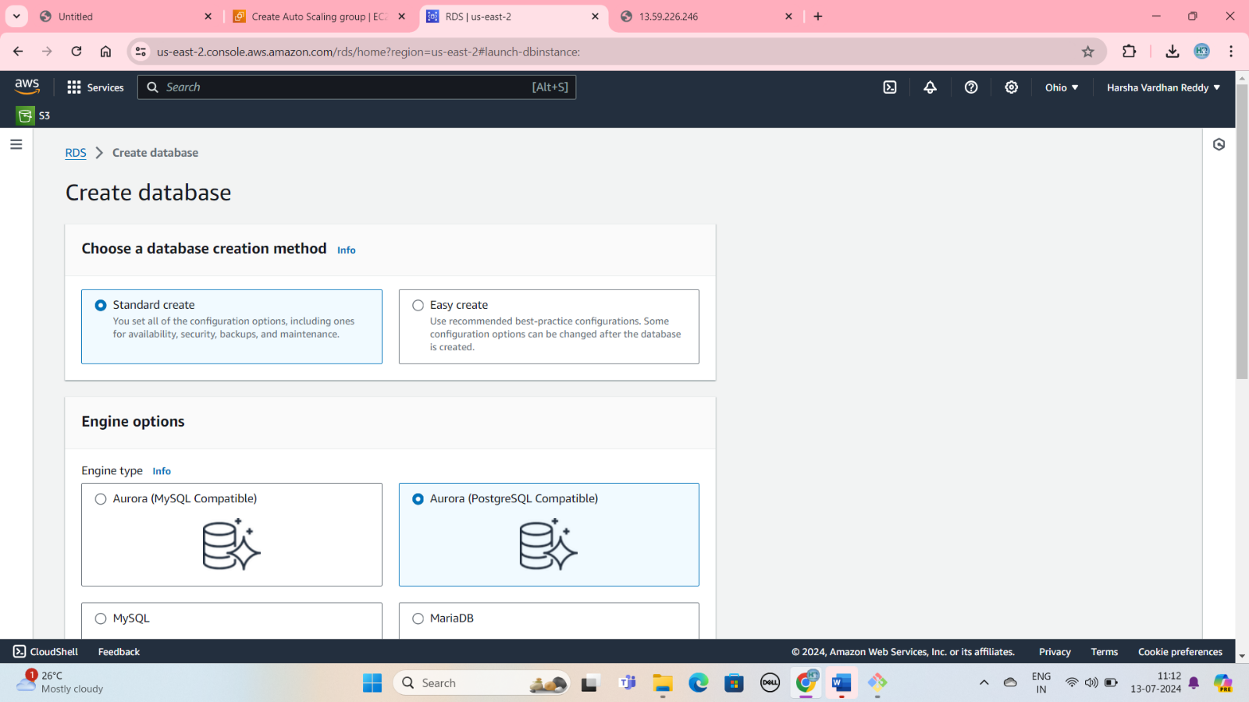

Availability and Durability Select the Multi-AZ DB Cluster:

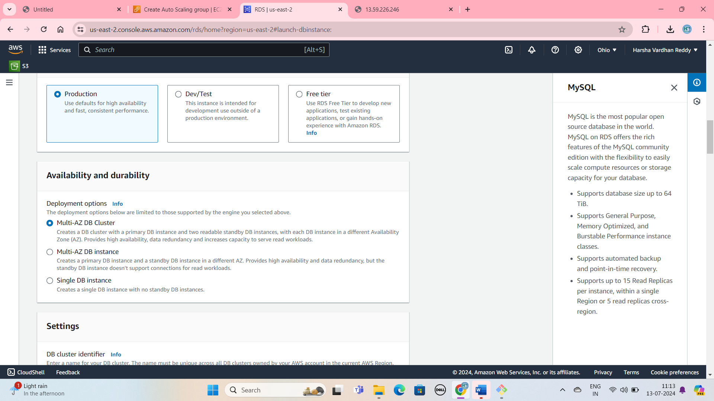

Select the Self managed and Generate Password:

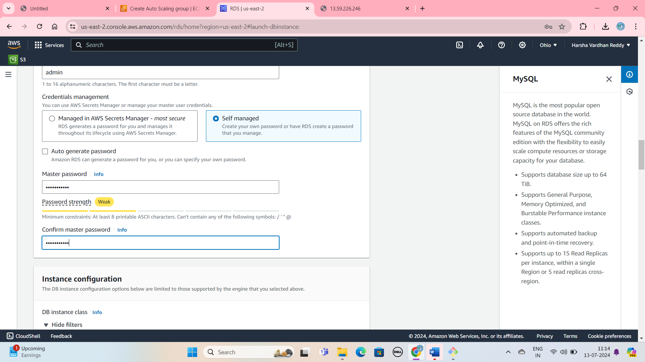

Created the RDS :

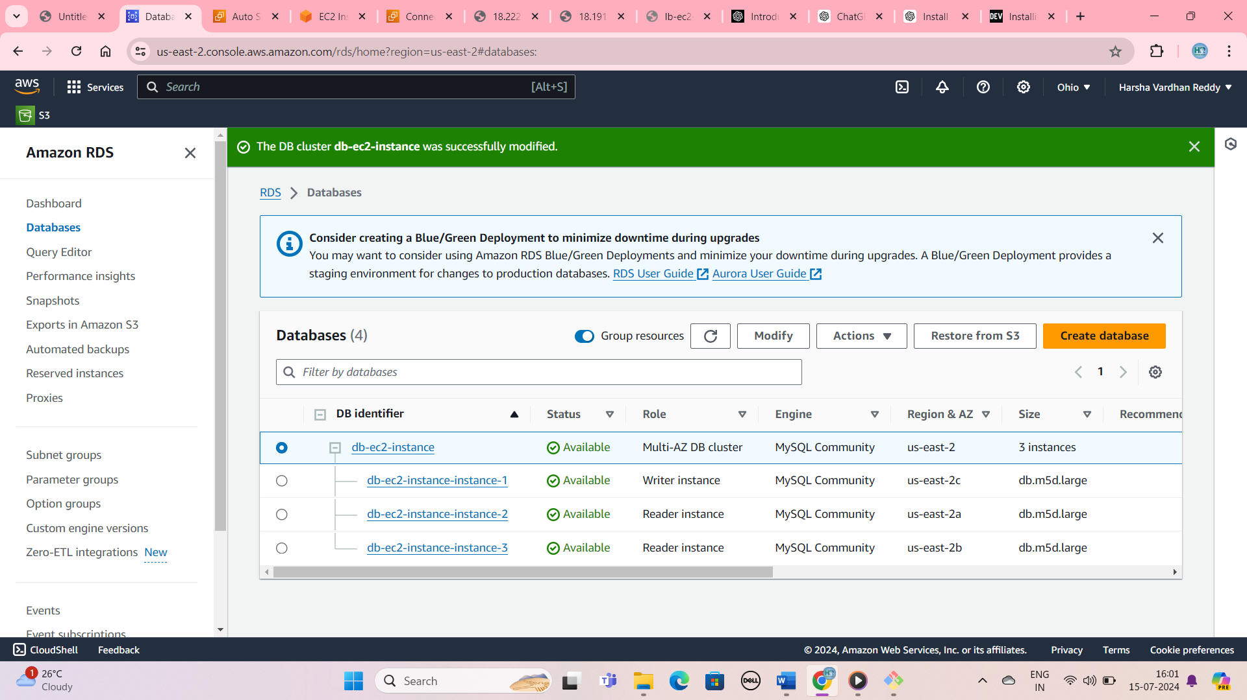

Copy the END POINT Name:

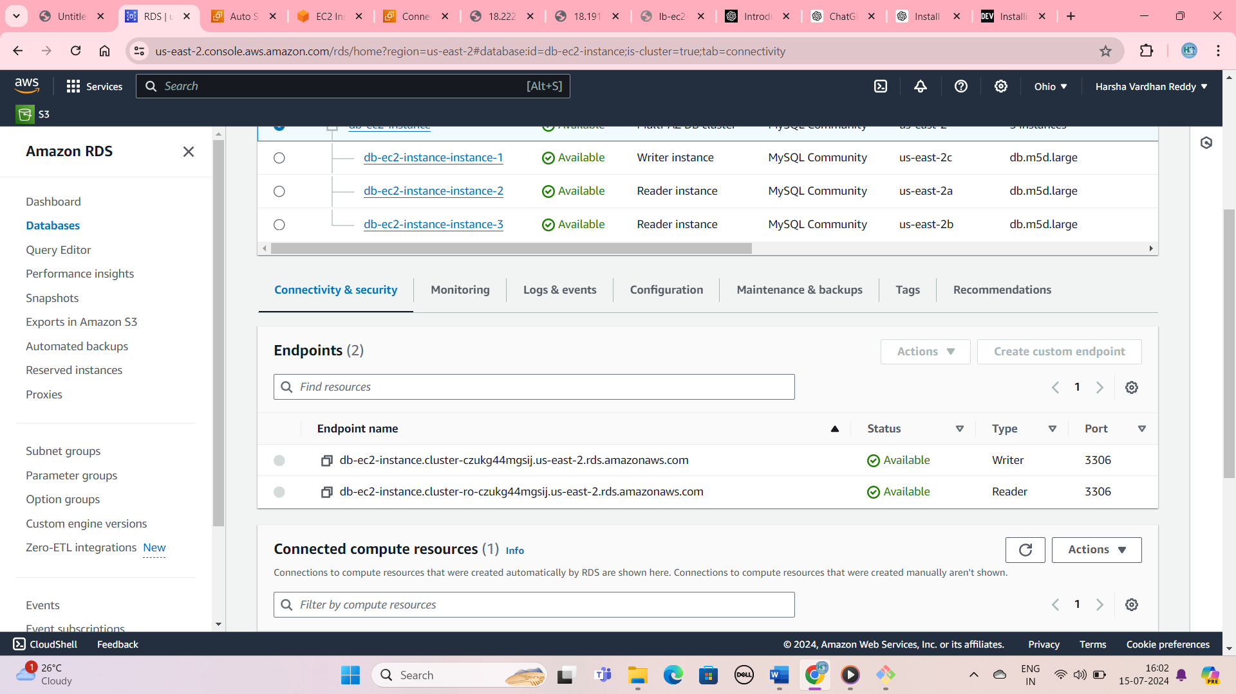

Paste the End point Commands MYSQL -h “end point” -u admin -p:

